ARGOS-Client IM Interface Document
Version 0.3

Technology Strategy Architecture
Date: 06/02/2011

Change History

Date | Author | Version | Description
10/27/2010 | Raman Mehta | 0.1 | First Version
11/04/2010 | Sakshi Mishra | 0.2 | Updated after review.
06/02/2011 | Rama Krishna Reddy | 0.3 | Updated as per CPT integration.

Table of Content

1 Introduction 4
2 Architecture 4
3 ARGOS Synch Utility – ARGOS Client Application Handshake 5
3.1 Client Application Interface (Producer) 5
3.2 Web Service Security 5
3.3 Synch Utility (Consumer) 5
4 ARGOS Client Interface Details 6
4.1 WSDL 6
4.2 Method Details 6
4.2.1 Method Signature 6
4.2.2 Method Input parameters 6
4.2.3 Method out put parameter 7

Introduction

ARGOS Client Application Synch utility is aimed at provision of new and modified (disabled) users from AD/OID repository to Client application.

The Client application can thereby process the user account and populate the user data store.

This document is meant for the developers and architects of ARGOS and Client Application involved in ARGOS integration projects.

Architecture

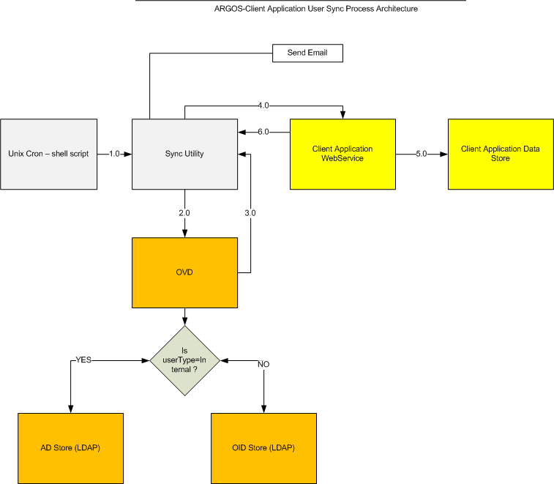

ARGOS Synch Utility – ARGOS Client Application Handshake

Client Application Interface (Producer)

The ARGOS client application is required to design and develop a staging application which will process the user records sent by the client (Synch utility).

The above ARGOS client staging application will then expose its interfaces via Web-Services (SOAP/HTTP). Web-Services are Synchronous and support batching interface for all the Use-cases.

Endpoint |  | Information
Service Name: | {http://webservice.pcs.pearson.com/} <ClientAppName> SyncInterfaceImplService | Address: | http://<IP>:<PORT>/<CONTEXT-ROOT>/<ClientAppName> SyncInterfaceImplPort
Service Name: |  | WSDL: | http://<IP>:<PORT>/<CONTEXT-ROOT>/<ClientAppName> SyncInterfaceImplPort?wsdl
Port Name: | {http://webservice. <ClientAppName>.pearson.com/} PcsSyncInterfaceImplPort | Implementation class: | com.pearson. <ClientAppName>.sync.webservice.PCSInterfaceImpl

Web Service Security

- Argos recommends running web service on secured protocol (HTTPS).
- To make sure that only trusted client (Argos IM) is invoking the web service, client authentication is required. While invoking the web service Argos IM will provide the encrypted login credentials, web service will decrypt the login credentials and validate against the values stored in the configuration file.
- On successful validation of login credentials web service will precede further, else returns an authentication failure error to Argos IM.

Synch Utility (Consumer)

The ARGOS Client-ARGOS Synch Utility will run as a batch job on nightly basis and will fetch the delta user list which fall under the category of following use cases:-

- New additions
- Modified (user account update/disable)

The utility will then invoke the above mentioned ARGOS Client’s interface’s exposed methods and pass on the list of users and the details as per the use case.

After receiving the input the ARGOS Client staging application will process the list accordingly and perform the desired DB operation. It is then required to return back the return code in the response object to the Synch Utility for error verification purpose.

ARGOS Client Interface Details

WSDL

Web service should publish a single method named “process ()” which is used to create/update user account

Method Details

Web service should publish a single method named “process ()” which is used to create/update user account based on the “event” variable in UserRequestType object.

- If the event is “Create”, it indicates new user account should be created.
- If the event is “Update”, it indicates user account should be updated with variables “First Name, Last Name and email address” in the UserRequestType object.
- “Update” event also covers both enable/disable user account scenarios. If the “isDisabled” variable is true in the UserRequestType object, it indicates account should be disabled else account should be activated.

Method Signature

UserResponseType process(UserRequestType)

Method Input parameters

Input parameters of method “process()” as below.

String “ID”:- web service user id (encrypted).
String “password”:- web service password (encrypted).
UserRequestType “object”:- Object containing the user account details and event action to be performed.

UserRequestType Object syntax

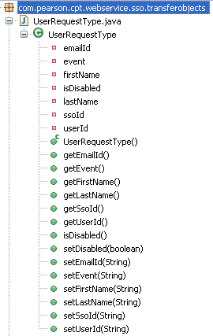

Method out put parameter

Web service method should return the object of type “UserResponseType”.

String “result”:- Is a constant (TRANSAC_SUCCESS/TRANSAC_FAIL) to indicate if the user account is processed successfully or not.

TRANSAC_SUCCESS:- Indicates web service processed the user account successfully.
TRANSAC_FAIL:- Indicates web service failed to process the user account.

String “dataReport”:- In case web service fails to process the user account (i.e. result is “TRANSAC_FAIL”), error message should be set in the “dataReport” variable of UserResponseType object.

UserResponseType Object syntax

